Food Nutrition classification.

Approach
- Food classification is done by considering the input features such as 'Calories', 'Protein', 'Fat', 'Carbs', 'Sugar', 'Fiber', 'Sodium', 'Cholesterol', 'Glycemic_Index' and 'Water_Content' and output value will be ‘Food_Name’.
- Models such as Logistic regression, XG booster, Decision tree matrix, Random forest, K nearest neighbour, Support vector machine and gradient booster are used to compare the outputs.
- Model performance is measured based on Accuracy score.
- Process:
  - Raw data is imported and checke the data and removed the not required rows such as null value and duplicates.
  - Pairplot is formulated for food and nutritions.
  - Done the feature engineering by using the PCA.
  - IQR has been formulated.
  - Food name is predicted by using various models and confusion matrix plotted.

Data analysis
- Total there are 31700 rows and 16 columns.
- In provided data serving size is not consistent even among the same foods.
- There were total 375 rows with missing data in nutrition columns and those are dropped.
- Duplicates columns are dropped.
- Below image shows the food class distritbution.
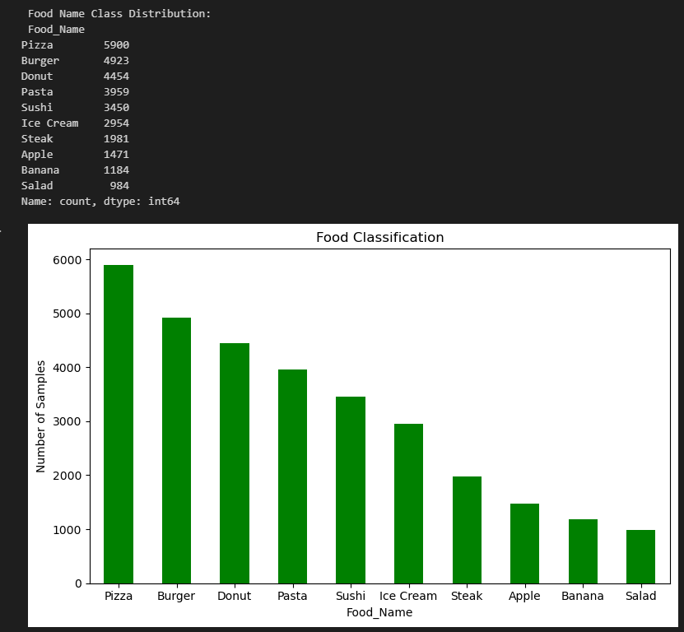
- Pairplot between food and nutrition shows the below points.
  - When there is increase in fat and carbs, value of calorie is on the raise.
  - Sugar and caloris doesn’t have the linear relationship.
  - High water content usually reduces the food GI.
- PCA:
  - PC1 (X-axis) explains 38.7% of the variance
  - PC2 (Y-axis) explains 24.1% of the variance
  - Together: ~63% of nutritional information is captured
  - PCA visualization shows clear clustering of food categories based on nutritional composition. Low-calorie foods such as fruits and salads cluster on the left, while fried, high calorie and processed foods such as burgers, donuts, and pizza appear on the right. Protein- and fat-rich foods like steak are separated along the second principal component, indicating distinct macronutrient profiles
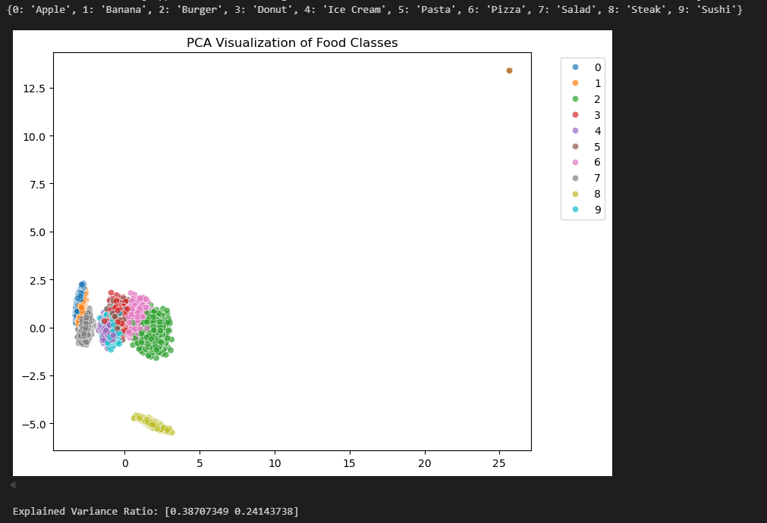
- Statistical analysis.
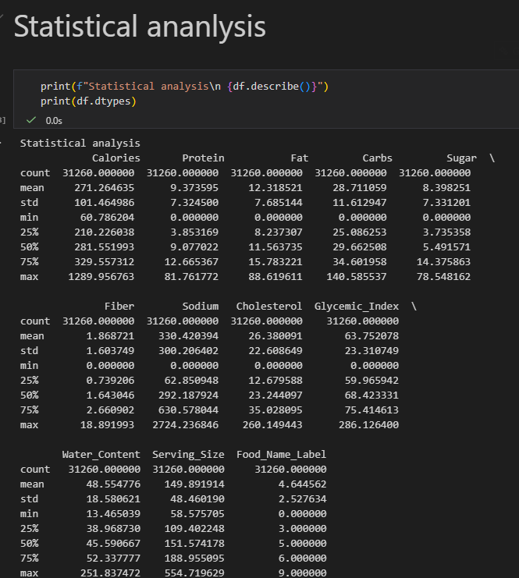

- IQR and outliers.
  - Water content, GI, carbs and cholesterol has the high number of outiers where as sodium, sugar and calories has less number of outliers.
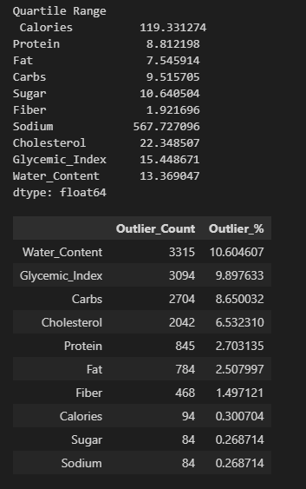

Model selection and evaluation

All the models which are tested gave good result of above 99%. Which shows the models are performing good.
Model | Accuracy
Logistic Regression | 99.23%
Decision tree | 98.59%
Random Forest | 99.41%
KNN | 99.23%
SVM | 99.47%
XG boost | 99.34%
Gradient boost | 99.38%

Confusion matrix shows very minimal discripency in prediction.
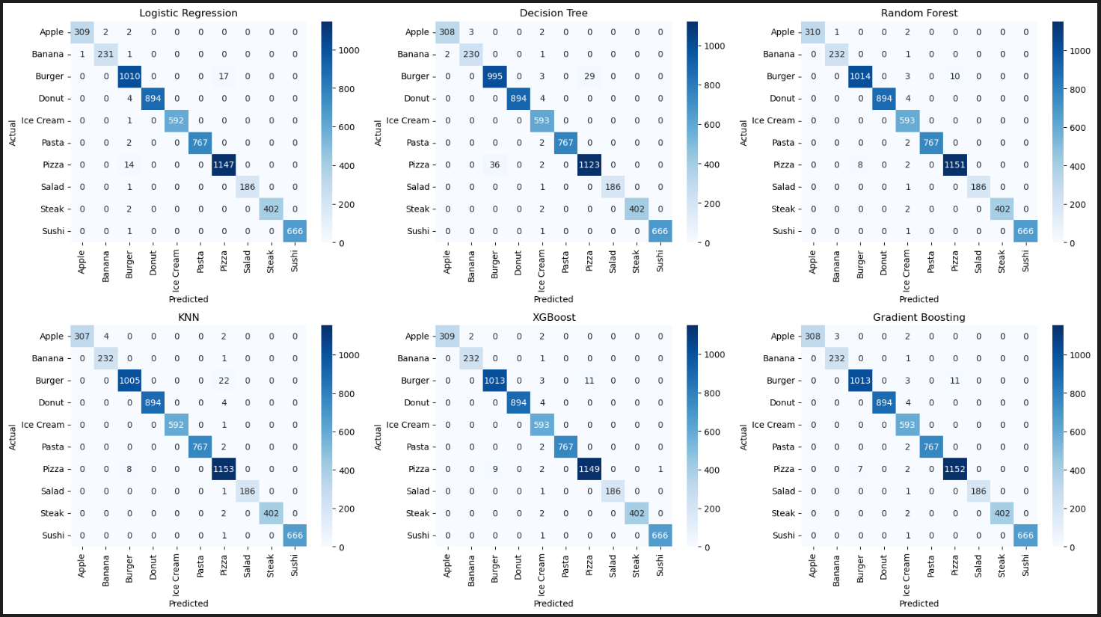
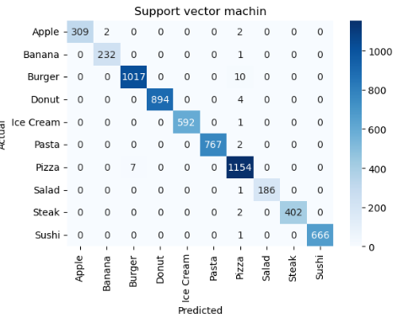

Food Nutrition with 100 gram.

Have performed one test by converting the nutrition value per 100 gram serving. Have performed all the above mentioned analysis with 100gram converted data.
- PCA
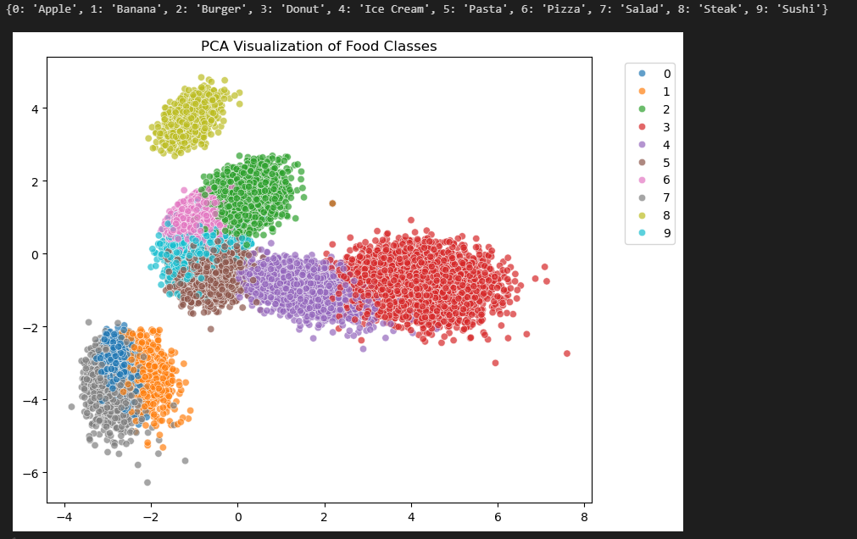

- IQR and outliers GI has more outliers compar to the data and outliers are more with converted data.
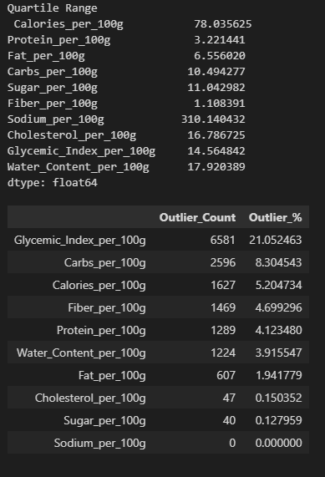

- Model accuracy for 4 models are slightly better with converted data and for 2 models performed better with original data.
Model | Accuracy
Logistic Regression | 99.38%
Decision tree | 98.86%
Random Forest | 99.34%
KNN | 99.42%
XG boost | 99.46%
SVM | 99.65%
Gradient boost | 99.36%

